Chapter 1 Overview

The overarching theme of biology is: EVOLUTION

Subthemes:
1. New properties emerge at each level in the biological hierarchy

2. Organisms interact with their environments, exchanging matter and energy

3. Structure and function are correlated at all levels of biological organizations

4. Cells are an organism’s basic units of structure and function

5. The continuity of life is based on heritable information in the form of DNA

6. Feedback mechanisms regulate biological systems

Levels of Biological Organization
1. Biosphere 6. Organs and organ systems

2. Ecosystems 7. Tissues

3. Communities 8. Cells

4. Populations 9. Organelles

5. Organisms 10. Molecules

CHARLES DARWIN came up with the theory of natural selection.

This later established a Tree of Life.

We group species. However before we do this, one must decide which domain an organism belongs to.

1. Domain Bacteria

2. Domain Archaea

3. Domain Eukarya
**Domain bacteria and archaea are both prokaryotic*
To study natural phenomenon, two types of study methods can be used:

- Discovery Science

- Hypothesis-Based Science

Hypothesis-based science=scientific method

(Don’t hate me, but we are going to list the steps)
1. Onservation

2. Address a question

3. Form a hypothesis

4. Perform an experiment

5. Collect data

6. Draw conclusions

Chapter 2:

1. Name the difference between atomic number and atomic mass. (Use Oxygen as an example)
atomic number=number of protons
atomic mass=number of protons + number of neutrons
Oxygen: atomic number=8, atomic mass=16 (8+8)

2. Show two different isotopes of carbon.
Carbon-12, carbon-13, carbon-14

3. An element of Uranium is hit with a particle that makes it miraculously lose 2 protons and 4 neutrons. What is the new element with mass number and new atomic number listed.
**assume atomic mass double the atomic number
Thorium: 90 protons, 178 atomic mass

4. Draw an example of an ionic bond, a covalent bond and a hydrogen bond.
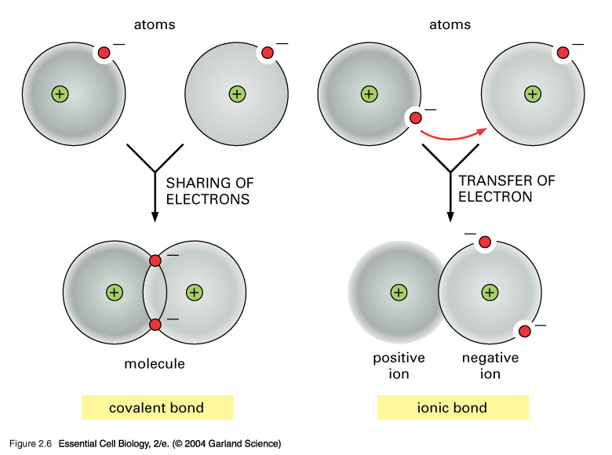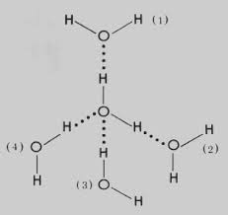

5. Describe emergent properties, give an example of what they do.
Properties of the elements in the compound are not necessarily the properties of the compound
Ex: sodium=extremely reactive metal; chlorine=toxic gas, when they come together, make table salt

