What phase of mitosis is this? How can you tell? What is different in this phase than in meiosis? What step becomes before and which comes after?
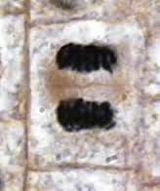
Telophase-can see faint line between two masses. In meiosis, first time homologous chromosomes are separated. Second time, sister chromatids are separated.
Before=anaphase, after-cytokinesis
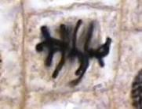
Metaphase-chromosomes lined up in center. Nothing different in meiosis except metaphase 1 lines up homologous chromosomes, 2 lines up sister chromatids.
Before-prometaphase, after-anaphase
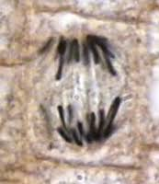
Anaphase=each chromatid on separate side of cell. Difference between what pulled.
Before=metaphase, after=telophase
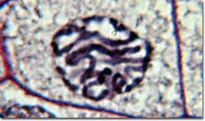
prophase. Can see chromosomes condensing. Prophase 1=crossing over, prophase 2=same
before=g2/interphase. After=prometaphase

In the cell cycle, where do checkpoints occur? What is associated with each stage?

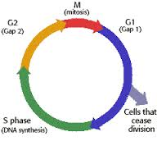
end of G1, end of G2 and mitosis.
S phase=synthesize DNA
Mitosis=cell division
G phases=cell growth, produce proteins and cytoplasmic organelles

Enzymes facts
Proteins that catalyze reactions, lower activation energy, no affect on change in free energy. Have a substrate. Can be both catabolic and anabolic
Have optimal pH and temp. If raise temp and lower pH, denature. If lower temp and increase pH, decrease speed.
Substrate specific
Allosteric regulation
Activators stabilize active form of enzyme, inhibitors stabilize the inactive form
Feedback inhibition: when produce excess product downstream, goes back and blocks production
Activation: produce some bind to produce more
Cooperativity: one substrate binds and makes enzyme have a higher affinity for the substrate

Inhibitors
Competitive: Bind right into active site

Noncompetitive: change shape of active site by binding in another place on the molecule.

