Cell Stuff
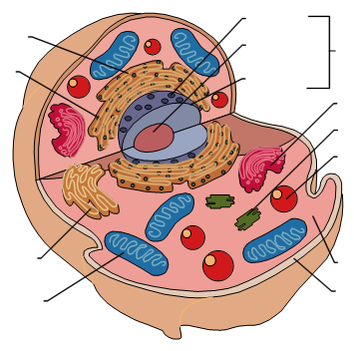

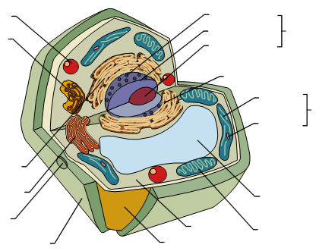

Draw a nucleotide

What are the bases that go together in DNA?

What are the purines? What are the pyrimidines?

