BY 123 Mock Exam-Biga

- You have applied a chemical to your windshield on your brand new expensive car. This chemical causes water to form droplets when it hits your windshield. What property of water is this chemical using?
  - Adhesion because the water is attracted to itself
  - Cohesion because the water is attracted to the windshield
  - Cohesion because the water is attracted to itself
  - Adhesion because the water is attracted to the windshield
  - Neither

- When a person stops breathing, carbon dioxide builds up in the blood causing the blood to turn acidic. What would be affected the most?
  - Energy production
  - Transport of molecules into the cell
  - Inactive sex hormones
  - Storage of energy
  - Cell membrane disintegration

- Which of the following would not affect secondary structure?
  - Sequence of amino acids
  - R-group interactions
  - Partial negative charge of oxygen
  - Inability to form alpha helices or beta-pleated sheets
  - Partial negative charge of nitrogen

- Which of the following would you not expect to see in a prokaryotic cell?
  - Mitochondria
  - Ribosomes
  - DNA
  - Plasma membrane
  - Cytosol

- In your body, your muscles need energy to contract. Which of the following organelles would you expect to be overly present in a muscle cell?
  - Rough endoplasmic reticulum
  - Mitochondrion
  - Ribosomes
  - Golgi apparatus
  - Central vacuole

- You discover an animal that can survive at drastically low temperatures and find that the cell membrane remains fluid. What causes this to happen?
  - Movement of the phospholipids
  - Unsaturated hydrocarbon tails
  - Cholesterol within the membrane
  - Transport proteins embedded in the membrane
  - Unkinked hydrocarbon tails

- Given the following molecule, which type of bond are you most likely to see?
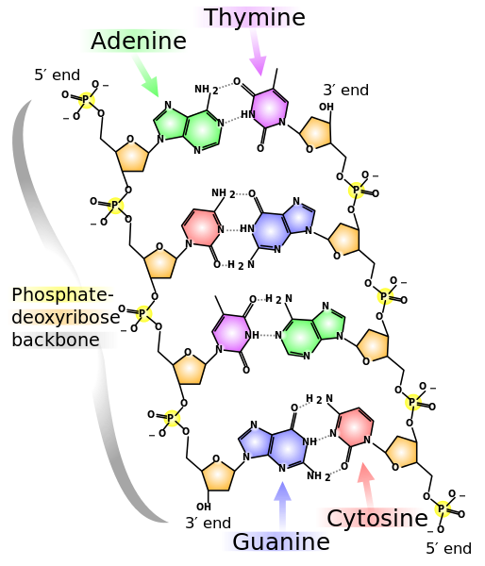
  - Glycosidic
  - Peptide
  - Ester linkage
  - Disulfide bridges
  - Phosphodiester linkage

- Which of the following are listed in proper order of levels of biological organization (largest to smallest)?
  - Rainforest, poison dart frog, amphibians `
  - New York City, ducks in Central Park, cartilage
  - Swamp, methane, alligators
  - Mitochondria, ATP, muscle
  - Great Barrier Reef, Dorie, the drop-off

- Which of the following would you expect to not have a nucleus/nuclei?
  - E. coli
  - Muscle cells
  - Mushrooms
  - Moss on a rock
  - Amoeba

- If you had an element with 97 protons and 45 neutrons and had a radioactive particle released that caused 4 protons to be released and the mass number to decrease by 9, how many protons and neutrons would you end up with?
  - 93, 142
  - 89, 45
  - 93, 36
  - 97, 36
  - 93, 40

- Of the following elements, which of their valence shells would be expected to have the highest potential energy?
  - Oxygen
  - Lithium
  - Iodine
  - Neon
  - Potassium

- Which of the following would you expect to be least water-soluble?
  - Phospholipids
  - Triglyceride
  - Single amino acid
  - Potassium ion
  - Nucleic acid

- Which of the following would require ATP to be used?
  - Movement of water into a cell when the cell has a lower water content than the environment
  - Nonpolar small molecules entering the cell
  - Channel proteins carrying ions into the cell
  - Sodium being pumped out of the cell into the extracellular fluid with a greater positive charge than within the cell.
  - Flow of glucose into an energy deprived cell

- To get low density lipoproteins into a cell:
  - Directly cross plasma membrane
  - Enter by endocytosis
  - Enter under active transport
  - Enter via aquaporins
  - Enter via transporter proteins

- Which of the following functional groups would be found in amino acids?
  - Sulfhydryl
  - Amino
  - Carboxyl
  - B and C
  - A, B and C
- Which of the following functional groups would not be found in a monosaccharide?
  - Carboxyl
  - Carbonyl
  - Hydroxyl
  - Amino
  - A and D

- You have been given a compound in which you know has structural isomers. What would be true of those isomers?
  - All would have the same properties
  - Would contain an asymmetric carbon
  - They would differ in arrangement around a double bond
  - They would have differing number of carbon but the same total elements to make up the molecule
  - They would differ in branching

- Of the following nitrogenous bases, which would not have the capability to pair together?
  - Adenine and thymine
  - Guanine and cytosine
  - Thymine and uracil
  - Adenine and cytosine
  - C and D

- Which of the following does not happen?
  - Chloroplasts in a plant cell
  - Central vacuole in an animal cell
  - Lysosomes in both animal and plant cells
  - A and C
  - B and C

- Which of the following organelles would not be involved in protein synthesis?
  - Nucleus
  - Rough endoplasmic reticulum
  - Lysosome
  - Ribosome
  - Golgi apparatus

- By simple diffusion:
  - Water will flow into a hypertonic cell
  - Water will flow into a hypotonic cell
  - Water will flow out of a isotonic cell
  - There will be no diffusion of water into an isotonic cell
  - Water will flow into an isotonic cell.

- Which of the following would not be suspected to use channel transport?
  - Hydrogen ions
  - Sodium ions
  - Amino acids
  - O₂
  - Water

- Which of the following organelles best illustrate the theme “organisms interact with their environments, exchanging matter and energy?
  - Chloroplasts
  - Mitochondria
  - Lysosome
  - A and B
  - None of the above

- When placed in a basic solution water:
  - Acts as a buffer
  - Donates hydrogen ions to solution
  - Accepts hydrogen ions from solution
  - A and B
  - A and C

- Which functional group(s) is (are) present in this molecule?
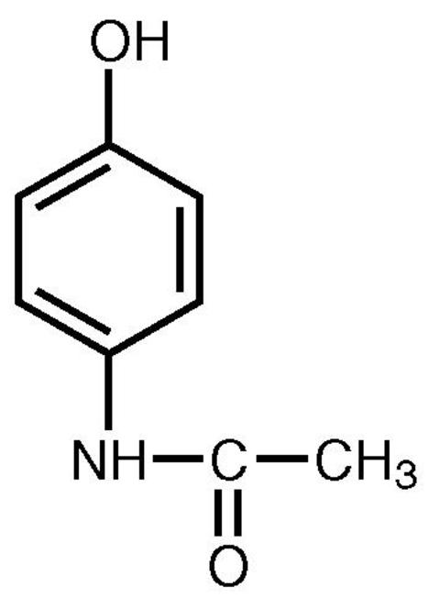
  - Carbonyl
  - Carboxyl
  - Methyl
  - A and C
  - A and B

26) A corresponds to .
  - Glycosidic bond, lipids
  - ATP, passive transport
  - Microfilaments, movement
  - Microtubules, desmosomes
  - Degradation, endoplasmic reticulum
- Given the DNA sequence 5’-ACTGCGATCGTA-3’, which DNA sequence would be its pair?
  - 5’-TGACGCTAGCAT-3’
  - 5’-ACTGCGATCGTA-3’
  - 5’-TACGATCGCAGT-3’
  - 5’-ACTGCGATCGTA-3’
  - 5’-TCAGCGTAGGCT-3’

- A virus does not have it’s own way of giving rise to other viruses. It hijacks another cell and causes the host cell to produce more viruses. Does this follow cell theory? Why?
  - Yes, all cells arise from preexisting living cells
  - Yes, all organisms are composed of one or more cells
  - Yes, the cell is the most basic unit of structure, function and organization is all organisms.
  - No, violates all cells arise from preexisting cells
  - None of the above.

- In your pancreas, there are special cells that produce the hormone insulin. Insulin is a protein that is composed of 4 distinct units of proteins. What is the final structure of insulin and what type of organelle would you expect to be overly present in the pancreas?
  - Tertiary, rough endoplasmic reticulum
  - Tertiary, Golgi apparatus
  - Quaternary, smooth endoplasmic reticulum
  - Quaternary, rough endoplasmic reticulum
  - Tertiary, smooth endoplasmic reticulum

- Which structure does not correspond to the listed function?
  - Mitochondrionenergy production
  - Ribosomeprotein synthesis
  - Lysosomeforms hydrogen peroxide
  - Nucleus synthesis of rRNA
  - Golgi apparatus modification of phospholipids

- Given the following RNA transcript, what would be its corresponding DNA strand? 5’-UGCACGUACCGGAU-3’
  - 5’-ACGUGCAUGGCCUA-3’
  - 5’-AUCCGGUACGUGCA-3’
  - 5’-ATCCGGTACGTGCA-3’
  - 5’-ACGTGCATCCGGTA-3’
  - 5’-TUCCGGUTCGUGCA-3’

- When the following molecule forms a polymer, what type of bond does it use?
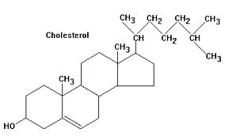
  - Glycosidic bond
  - Peptide bond
  - Phosphodiester linkage
  - Ester bond
  - None of the above

- When a certain poison enters the cell, it attaches itself to a protein within an organelle responsible for detoxification. What organelle would be affected?
  - Smooth endoplasmic reticulum
  - Golgi apparatus
  - Rough endoplasmic reticulum
  - Mitochondrion
  - Ribosome

- For a cell to receive food, it engulfs the surrounding fluid into vesicles to receive nutrients. What is this process called?
  - Exocytosis
  - Phagocytosis
  - Receptor-mediated pinocytosis
  - Pinocytosis
  - Receptor-mediated endocytosis

- In the neuron, a membrane protein allows sodium to enter down its concentration gradient when a neurotransmitter is bound to the protein. This protein is known as
  - Ion channel
  - Gated ion channel
  - Channel protein
  - Pump
  - Leak channel

- In the cell membrane, which of these structures do not correspond to their function?
  - Cholesterol increase fluidity
  - Glycolipidscell to cell recognition
  - Glycoproteins cell to cell recognition
  - Aquaporinspassage of water into cell membrane
  - Phospholipids allow polar particles to pass directly into the cell
- Which of the following functional groups are part of nucleotides?
  - Amino group
  - Carbonyl
  - Phosphate group
  - Carboxyl group
  - A, B and C

- Which of the following will enter the cell by facilitated diffusion?
  - Water
  - Sodium ions
  - Glucose
  - Oxygen
  - Amino acids

- A plant cell does all of the following except:
  - Contain a cell wall
  - Use plasmodesmata
  - Burst when placed in a hypotonic solution
  - Make glucose
  - Store nutrients in the central vacuole

- What contains more atoms: a mole of oxygen or a mole of carbon?
  - Mole of oxygen
  - Mole of carbon
  - Same

Corresponds to 40-42
One day, while you were drinking a carbonated beverage, you found that the pH was 5.
- What is the pOH?
  - 5
  - 10⁻⁵
  - 9
  - 10⁻⁹
  - 10⁻¹⁴

- What was the concentration of hydrogen ions?
  - 5
  - 10⁻⁵
  - 9
  - 10⁻⁹
  - 10⁻¹⁴

- What was the concentration of hydroxide ions?
  - 5
  - 10⁻⁵
  - 9
  - 10⁻⁹⁻
  - 10⁻¹⁴

- Which of the following functional groups will not cause a molecule to be polar or charged?
  - Hydroxyl
  - Carbonyl
  - Carboxyl
  - Phosphate
  - Amino

- Which of the following bonds form in exchange for a water molecule?
  - Glycosidic
  - Peptide
  - Phosphodiester
  - Hydrogen
  - A, B, C

- In the genetic code, there is a mutation that causes cysteine to be replaced with glycine. Which of the following structures will be affected?
  - Secondary
  - Tertiary
  - Primary
  - Quaternary
  - All of the above

- Which of the following organelles are hypothesized to once be bacteria that were incorporated into the cell
  - Lysosomes
  - Chloroplasts
  - Mitochondria
  - Peroxisomes
  - B and C

- Which of the following components of the cytoskeleton would not be utilized in muscle contraction?
  - Microtubules
  - Microfilaments
  - Intermediate filaments
  - A and B
  - A and C

- To have cotransport, one would need?
  - Energy
  - An electrogenic pump
  - A concentration gradient
  - A and B
  - A, B and C

- Which of the following go together?
  - Intermediate filaments gap junctions
  - Plasmodesmata gap junctions
  - Intermediate filaments tight junctions
  - A and B
  - B and C

- Which of the following are examples of enantiomers?
  - Ethane and ethanol
  - R-Ibuprofen and S-Ibuprofen
  - L-glucose and D-glucose
  - Cis ethene and trans ethene
  - B and C

